The Second International Cosmic Ray Workshop

“ARAGATS 2011”

September 12 - 16, 2011

Nor-Amberd, Yerevan, Armenia

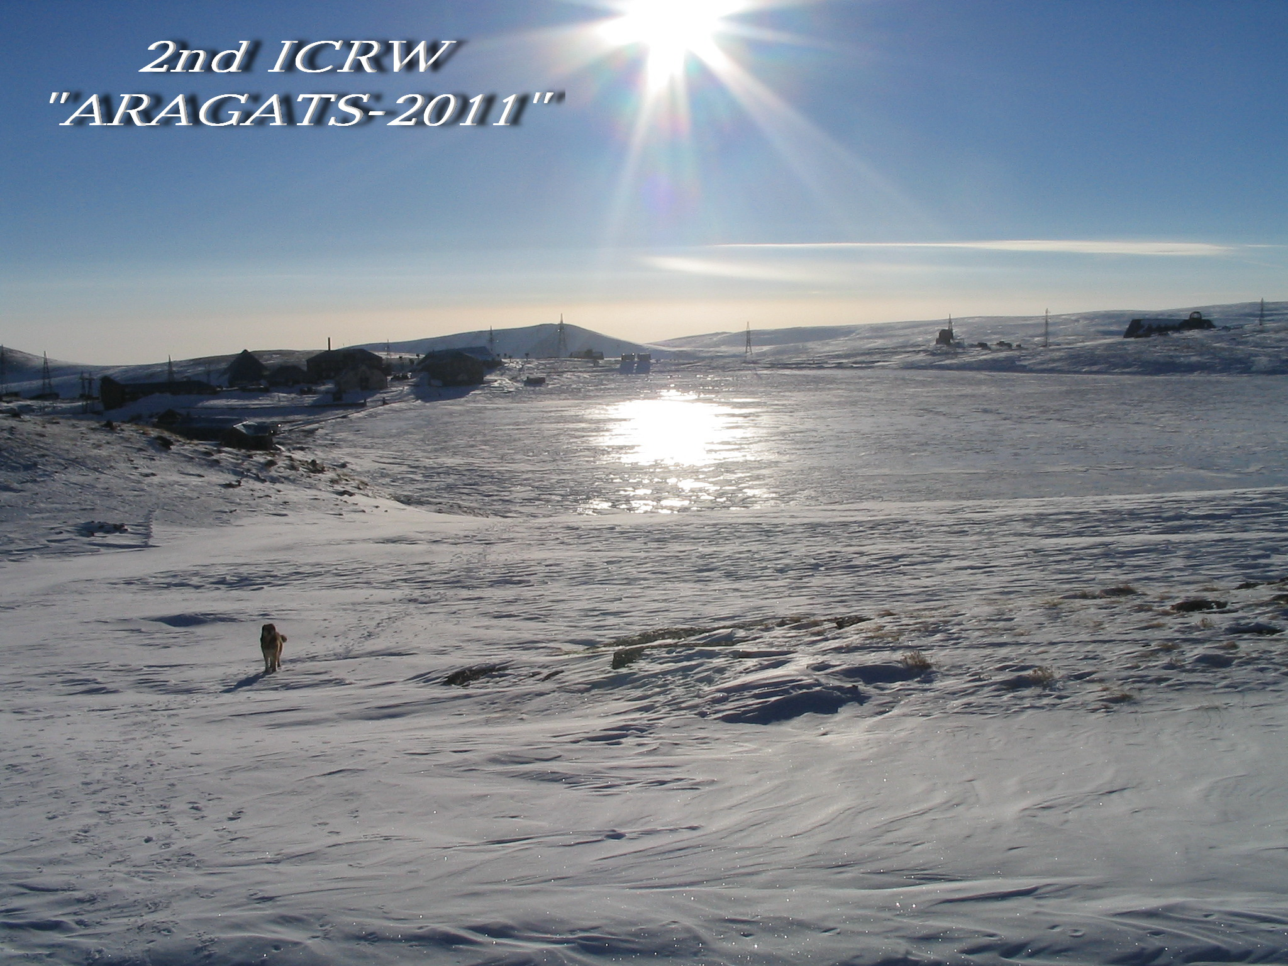

First Bulletin
(The complete version of the First Bulletin can be found on the Web site
http://gamma-armenia.org/ICRW-Aragats-2011/)

Place and date

The 2nd International Cosmic Ray Workshop (ICRW) “ARAGATS 2011” will take place from 12th to 16th of September, 2011 at “Nor-Amberd International Conference Center” of the A.I. Alikhanyan National Science Laboratory (former Yerevan Physics Institute), which is located 40 km North-West of Yerevan. The elevation is 2000 m a.s.l.

Committees

International Advisory Committee

R. Martirosov (A.I. Alikhanyan National Science Laboratory, Armenia), Co-Chair
O. Dalkarov (P.N. Lebedev Physical Institute, Russia), Co-Chair
A. Chilingaryan (A.I. Alikhanyan National Science Laboratory, Armenia)
A. Erlykin (P.N. Lebedev Physical Institute, Russia)
Y. Gallant (University of Montpellier II, France)
S. Gupta (Tata Institute of Fundamental Research, India)
A. Haungs (Institut für Kernphysik Forschungszentrum, Karlsruhe, Germany)
L. Jones (University of Michigan, U.S.A.)
J. Kempa (Warsaw University of Technology, Poland)
M. Panasyuk (Institute of Nuclear Physics of the Moscow State University, Russia)
B. Pattison (CERN, Switzerland)
A. Petrukhin (National Research Nuclear University MEPhI, Russia)
V. Sahakyan (State Committee of Science, Armenia)
Yu. Stozhkov (P.N. Lebedev Physical Institute, Russia)
S. Ter-Antonyan (Southern University, Baton Rouge, USA)
A. Wolfendale (Durham University, United Kingdom)

Local Organizing Committee

R. Martirosov, Chair (A.I. Alikhanyan National Science Laboratory)
A. Barsegyan (Fund “Nor-Amberd Scientific Center”)
A. Garyaka (A.I. Alikhanyan National Science Laboratory)
T. Hambardzumyan (A.I. Alikhanyan National Science Laboratory)
L. Mikaelyan (A.I. Alikhanyan National Science Laboratory)
Sh. Khachatryan (Yerevan “GALIK” University)
H. Babayan (State Engineering University of Armenia)

Scientific Program and Contributions

Cosmic rays in the 1 PeV - 1 EeV energy region:
- Origin of Cosmic Rays;
- Primary energy spectra and mass composition;
- Phenomenology of Extensive Air Showers;
- High energy interaction models and LHC data;
- Very-high energy gamma rays and gamma ray astronomy;
- Shower arrays and particle detectors.

The Workshop will be organized as a series of plenary sessions. Reports accepted for presentation at the Workshop will be either oral or poster. The official language of the Workshop is English.
The average allocated time:
for reviews – 40 min + 5 min discussion;
for other presentations – 20 min + 5 min discussion.

Please, use PowerPoint or PDF formats for your presentation. The files of presentations should be uploaded directly to the conference computer no later than the day preceding the talk.

Proceedings

The contributions at the Workshop will be published in a special proceedings book.
Additional information will be available in the Second Bulletin and on the Web site of the Workshop at: http://gamma-armenia.org/ICRW-Aragats-2011/

Important Dates

Starting date for registration | 1/03/2011
Deadline for registration | 30/06/2011
Deadline for abstract submission | 30/06/2011
Deadline for paper submission | 31/10/2011
Opening Ceremony | 12/09/2011
Workshop Closing | 16/09/2011

Sponsors

The Workshop “ARAGATS 2011” is hosted by
the A.I. Alikhanyan National Science Laboratory and the P.N. Lebedev Physical Institute with additional support from the State Committee of Science of the Republic of Armenia and the Armenian Fund in France

Registration Desk

The registration desk will be open:
on Sunday September 11th: from 10 a.m. to 5 p.m.
on Monday September 12th: from 10 a.m. to 1 p.m.

Registration Fee

The registration fee for the Workshop participants is 400 Euro. It includes:
- transportation from the airport to the Workshop site and back;
- shared double room;
- three meals a day;
- coffee breaks;
- one-day visit to the Aragats scientific station (3200m a.s.l.);
- excursion;
- conference bag with a book of abstracts;
- welcome reception and banquet.
The registration fee must be paid cash in EURO, US dollars or Russian rubles (corresponding amount) at the registration desk.

Computer Facilities

During the Workshop the wireless Internet connection will be available.

How to Register

Registration can only be made through the Internet. Please refer to the site of the ICRW “ARAGATS 2011” (http://gamma.yerphi.am/ICRW-Aragats-2011/) and follow the link to the registration form.

Contacts

Romen Martirosov: romenmartirosov@rambler.ru; martir@yerphi.am
Phone: (374-10) 34 19 00

Tatyana Hambardzumyan: tanja@yerphi.am
Phone: (374-10) 34 15 00

NOTIFICATION: The Second Bulletin with additional information and scientific program will be issued not later than July.

