Table 1. The EAS intensities measured by the MAKET-ANI detector in 1997-2004. The error bars are statistical. The corrections according to calculated response function are made.
N_{e} | S_{eff} ·T  x10¹¹  (m²·s) | dJ(θ)/dN_{e}  (m²·s·sr·N_{e})⁻¹  0º - 23.8º | dJ(θ)/dN_{e} .  (m²·s·sr·N_{e})⁻¹  23.8º -32.4º | dJ(θ)/dN_{e} .  (m²·s·sr·N_{e})⁻¹  32.4º –38.5º | dJ(θ)/dN_{e}  (m²·s·sr·N_{e})⁻¹  38.5º –43.º | dJ(θ)/dN_{e}  (m²·s·sr·N_{e})⁻¹  43.º –46.8º
1.12·10⁵  1.41·10⁵  1.77·10⁵  2.23·10⁵  2.81·10⁵  3.53·10⁵  4.45·10⁵  5.60·10⁵  7.05·10⁵  8.87·10⁵  1.12·10⁶  1.41·10⁶  1.77·10⁶  2.23·10⁶  2.81·10⁶  3.54·10⁶  4.43·10⁶  5.59·10⁶  7.03·10⁶  8.87·10⁷  1.12·10⁷  1.39·10⁷  1.78·10⁷  2.20·10⁷ 2.75·10⁷ | 1.06  -  -  -  1.29  -  -  -  1.55  1.83  2.13  2.46  2.82  -  -  -  -  -  -  -  -  -  -  -  - | (1.03 ± 0.01)·10⁻¹⁰  (5.70 ± 0.01)·10⁻¹¹  (3.18 ± 0.01)·10⁻¹¹  (1.77 ± 0.01)·10⁻¹¹  (1.00 ± 0.04)·10⁻¹¹  (5.61 ± 0.03)·10⁻¹²  (3.15 ± 0.02)·10⁻¹²  (1.77 ± 0.01)·10⁻¹²  (1.01 ± 0.08)·10⁻¹²  (5.62 ± 0.05)·10⁻¹³  (3.12 ± 0.03)·10⁻¹³  (1.73 ± 0.02)·10⁻¹³  (9.05 ± 0.19)·10⁻¹⁴  (5.06 ± 0.08)·10⁻¹⁴  (2.48 ± 0.05)·10⁻¹⁴  (1.30 ± 0.03)·10⁻¹⁴  (6.76 ± 0.22)·10⁻¹⁵  (3.47 ± 0.13)·10⁻¹⁵  (1.58 ± 0.08)·10⁻¹⁵  (8.36 ± 0.53)·10⁻¹⁶  (3.87 ± 0.34)·10⁻¹⁶  (2.31 ± 0.22)·10⁻¹⁶  (1.17 ± 0.14)·10⁻¹⁶  (6.04 ± 0.92)·10⁻¹⁷  (2.77 ± 0.58)·10⁻¹⁷ | (6.56 ± 0.01)·10⁻¹¹  (3.64 ± 0.01)·10⁻¹¹  (2.02 ± 0.01)·10⁻¹¹  (1.14 ± 0.01)·10⁻¹¹  (6.45 ± 0.04)·10⁻¹²  (3.65 ± 0.03)·10⁻¹²  (2.05 ± 0.02)·10⁻¹²  (1.14 ± 0.01)·10⁻¹²  (6.60 ± 0.07)·10⁻¹³  (3.61 ± 0.05)·10⁻¹³  (2.03 ± 0.03)·10⁻¹³  (1.12 ± 0.02)·10⁻¹³  (5.78 ± 0.11)·10⁻¹⁴  (2.93 ± 0.07)·10⁻¹⁴  (1.59 ± 0.05)·10⁻¹⁴  (8.09 ± 0.31)·10⁻¹⁵  (4.08 ± 0.19)·10⁻¹⁵  (2.07 ± 0.13)·10⁻¹⁵  (1.07 ± 0.08)·10⁻¹⁵  (5.03 ± 0.48)·10⁻¹⁶  (2.97 ± 0.35)·10⁻¹⁶  (1.42 ± 0.21)·10⁻¹⁶  (9.30 ± 1.39)·10⁻¹⁶  (3.87 ± 0.84)·10⁻¹⁷  (2.77 ± 0.59)·10-¹⁷ | (3.96 ± 0.02)·10⁻¹¹  (2.24 ± 0.01)·10⁻¹¹  (1.27 ± 0.01)·10⁻¹¹  (7.27 ± 0.06)·10⁻¹²  (4.06 ± 0.04)·10⁻¹²  (2.33 ± 0.03)·10⁻¹²  (1.31 ± 0.02)·10⁻¹²  (7.51 ± 0.11)·10⁻¹³  (4.33 ± 0.08)·10⁻¹³  (2.40 ± 0.04)·10⁻¹³  (1.27 ± 0.03)·10⁻¹³  (6.80 ± 0.16)·10⁻¹⁴  (3.72 ± 0.11)·10⁻¹⁴  (1.95 ± 0.07)·10⁻¹⁴  (1.00 ± 0.04)·10⁻¹⁴  (5.06 ± 0.28)·10⁻¹⁵  (2.54 ± 0.17)·10⁻¹⁵  (1.11 ± 0.10)·10⁻¹⁵  (6.04 ± 0.66)·10⁻¹⁶  (4.28 ± 0.51)·10⁻¹⁶  (1.59 ± 0.28)·10⁻¹⁶  (1.03 ± 0.10)·10⁻¹⁶  (4.65 ± 1.19)·10⁻¹⁷  (3.26 ± 0.92)·10⁻¹⁷  (1.52 ± 0.52)·10⁻¹⁷ | (2.50 ± 0.02)·10⁻¹¹  (1.40 ± 0.01)·10⁻¹¹  (7.96 ± 0.08)·10⁻¹²  (4.51 ± 0.06)·10⁻¹²  (2.55 ± 0.03)·10⁻¹²  (1.45 ± 0.02)·10⁻¹²  (8.46 ± 0.15)·10⁻¹³  (4.69 ± 0.10)·10⁻¹³  (2.68 ± 0.06)·10⁻¹³  (1.45 ± 0.04)·10⁻¹³  (7.63 ± 0.21)·10⁻¹⁴  (4.19 ± 0.14)·10⁻¹⁴  (2.14 ± 0.09)·10⁻¹⁴  (1.13 ± 0.06)·10⁻¹⁴  (5.95 ± 0.38)·10⁻¹⁵  (2.91 ± 0.23)·10⁻¹⁵  (1.50 ± 0.15)·10⁻¹⁵  (8.38 ± 0.10)·10⁻¹⁶  (3.17 ± 0.61)·10⁻¹⁶  (2.60 ± 0.43)·10⁻¹⁶  (1.41 ± 0.30)·10⁻¹⁷  (5.50 ± 1.78)·10⁻¹⁷  (1.58 ± 0.79)·10⁻¹⁷  (2.28 ± 0.85)·10⁻¹⁸  (8.20 ± 4.80)·10⁻¹⁸ | (1.54 ± 0.02)·10⁻¹¹  (8.81 ± 0.10)·10⁻¹²  (4.93 ± 0.07)·10⁻¹²  (2.85 ± 0.05)·10⁻¹²  (1.62 ± 0.03)·10⁻¹²  (9.19 ± 0.20)·10⁻¹³  (5.38 ± 0.14)·10⁻¹³  (2.85 ± 0.09)·10⁻¹³  (1.61 ± 0.05)·10⁻¹³  (8.48 ± 0.32)·10⁻¹⁴  (4.58 ± 0.20)·10⁻¹⁴  (2.38 ± 0.12)·10⁻¹⁴  (1.24 ± 0.08)·10⁻¹⁴  (6.41 ± 0.47)·10⁻¹⁵  (3.08 ± 0.28)·10⁻¹⁵  (1.76 ± 0.21)·10⁻¹⁵  (1.01 ± 0.14)·10⁻¹⁵  (4.39 ± 0.78)·10⁻¹⁶  (2.39 ± 0.57)·10⁻¹⁶  (1.26 ± 0.38)·10⁻¹⁶  (6.20 ± 2.29)·10⁻¹⁷  (4.89 ± 1.61)·10⁻¹⁷  (1.98 ± 1.10)·10⁻¹⁷  (2.10 ± 0.99)·10⁻¹⁷  (7.46 ± 4.28)·10⁻¹⁸

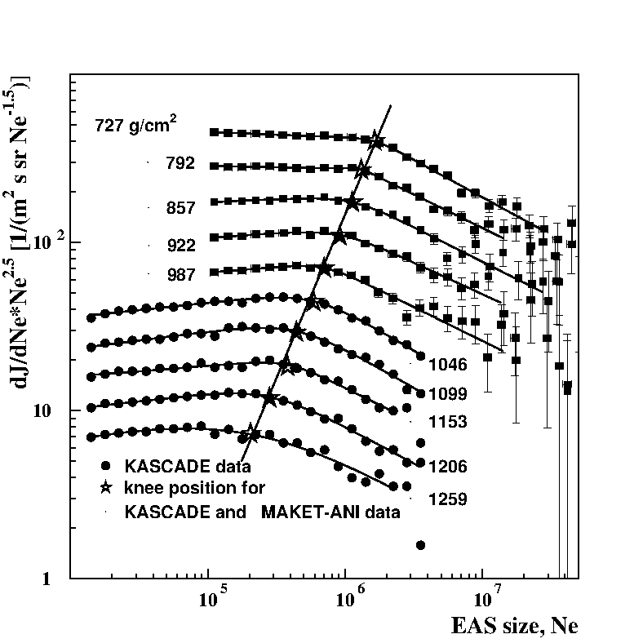
Fig 1. The size spectra measured by MAKET-ANI and KASCADE experiments. The slant depth covered by experiments comprises 720–1250 g/cm2. The solid line illustrates the EAS attenuation versus slant depth in the atmosphere.

Table 2. Parameters of the size spectra measured by MAKET-ANI array
Δθ(dgr.) | γ | Δγ | N_{e}^{knee} | A | δ | χ²(ndf)
0.0 – 23.8  23.8 – 32.4  32.4 – 38.5  38.5 – 43.0  43.0 – 46.8 | 2.53±0.002  2.52±0.002  2.47±0.003  2.45±0.003  2.44±0.006 | 0.45±0.02  0.43±0.02  0.47±0.03  0.45±0.03  0.48±0.04 | 1.58·10⁶±8·10⁴  1.33·10⁶±6·10⁴  1.08·10⁶±8·10⁴  0.86·10⁶±7·10⁴  0.70·10⁶±6·10⁴ | 641.79±11  333.32±8.5  114.37±3.8  53.60±2.6  29.18±2.2 | 7.1±1.7  11.6±3.0  3.9±0.8  4.4±1.6  4.7±1.4 | 1.1(19)  1.9(17)  1.2(19)  0.8(17)  0.9(16)

Table 3. The intensities of all CR, light and heavy nuclei groups.

Energy  (Gev) | dJ/dE ± stat.errors  [m⁻² s⁻¹ sr⁻¹ GeV⁻¹]  All particles | dJ/dE ± stat.errors  [m⁻² s⁻¹ sr⁻¹ GeV⁻¹]  Light | dJ/dE ± stat.errors  [m⁻² s⁻¹ sr⁻¹ GeV⁻¹]  Heavy
5.62·10⁵  7.07·10⁵  8.91·10⁵  1.12·10⁶  1.41·10⁶  1.77·10⁶  2.23·10⁶  2.81·10⁶  3.54·10⁶  4.46·10⁶  5.62·10⁶  7.07·10⁶  8.91·10⁶  1.12·10⁷  1.41·10⁷  1.77·10⁷  2.23·10⁷  2.81·10⁷  3.54·10⁷  4.46·10⁷  5.62·10⁷  7.79·10⁷  8.91·10⁷ | (8.620 ±0.022)·10⁻¹²  (6.716 ±0.017)·10⁻¹²  (4.587 ±0.012)·10⁻¹²  (2.582 ±0.008)·10⁻¹²  (1.342 ±0.005 )·10⁻¹²  (7.157 ±0.035 )·10⁻¹³  (3.821 ±0.023 )·10⁻¹³  (2.050 ±0.015 )·10⁻¹³  (1.104 ±0.010 )·10⁻¹³  (5.908 ±0.063 )·10⁻¹⁴  (2.986 ±0.040 )·10⁻¹⁴  (1.501 ±0.025 )·10⁻¹⁴  (7.305 ±0.158 )·10⁻¹⁵  (3.459 ±0.097 )·10⁻¹⁵  (1.640 ±0.059 )·10⁻¹⁵  (7.888 ±0.037 )·10⁻¹⁶  (4.073 ±0.235 )·10⁻¹⁶  (1.827 ±0.140 )·10⁻¹⁶  (8.368 ±0.845 )·10⁻¹⁷  (4.409 ±0.547 )·10⁻¹⁷  (2.747 ±0.385 )·10⁻¹⁷  (1.540 ±0.257 )·10⁻¹⁷  (6.799 ±1.520 )·10⁻¹⁸ | (6.920 ±0.019 )·10⁻¹²  (3.937 ±0.013)·10⁻¹²  (2.224 ±0.009)·10⁻¹²  (1.236 ±0.005)·10⁻¹²  (6.707 ±0.038)·10⁻¹³  (3.638 ±0.025)·10⁻¹³  (1.936 ±0.016)·10⁻¹³  (1.004 ±0.010)·10⁻¹³  (5.238 ±0.067)·10⁻¹⁴  (2.676 ±0.043)·10⁻¹⁴  (1.323 ±0.027)·10⁻¹⁴  (6.253 ±0.163)·10⁻¹⁵  (3.073 ±0.102)·10⁻¹⁵  (1.323 ±0.059)·10⁻¹⁵  (5.770 ±0.351)·10⁻¹⁶  (2.623 ±0.211)·10⁻¹⁶  (1.326 ±0.134)·10⁻¹⁶  (6.020 ±0.804)·10⁻¹⁷  (1.622 ±0.372)·10⁻¹⁷  (7.461 ±2.249)·10⁻¹⁸  (4.310 ±1.524)·10⁻¹⁸  (2.995 ±1.132)·10⁻¹⁸  (3.399 ±3.399)·10⁻¹⁹ | (1.700 ±0.010 ) ·10⁻¹²  (2.779 ±0.011 ) ·10⁻¹²  (2.362 ±0.009 ) ·10⁻¹²  (1.346 ±0.006 ) ·10⁻¹²  (6.722 ±0.038 ) ·10⁻¹³  (3.520 ±0.025 ) ·10⁻¹³  (1.886 ±0.016 ) ·10⁻¹³  (1.046 ±0.011 ) ·10⁻¹³  (5.810 ±0.070 ) ·10⁻¹⁴  (3.232 ±0.047 ) ·10⁻¹⁴  (1.664 ±0.030) ·10⁻¹⁴  (8.761 ±0.194) ·10⁻¹⁵  (4.233 ±0.121) ·10⁻¹⁵  (2.136 ±0.076) ·10⁻¹⁵  (1.064 ±0.048) ·10⁻¹⁵  (5.265 ±0.299) ·10⁻¹⁶  (2.748 ±0.193) ·10⁻¹⁶  (1.226 ±0.115) ·10⁻¹⁶  (6.746 ±0.759) ·10⁻¹⁷  (3.663 ±0.499) ·10⁻¹⁷  (2.317 ±0.353) ·10⁻¹⁷  (1.241 ±0.230) ·10⁻¹⁷  (6.459 ±1.482) ·10⁻¹⁸

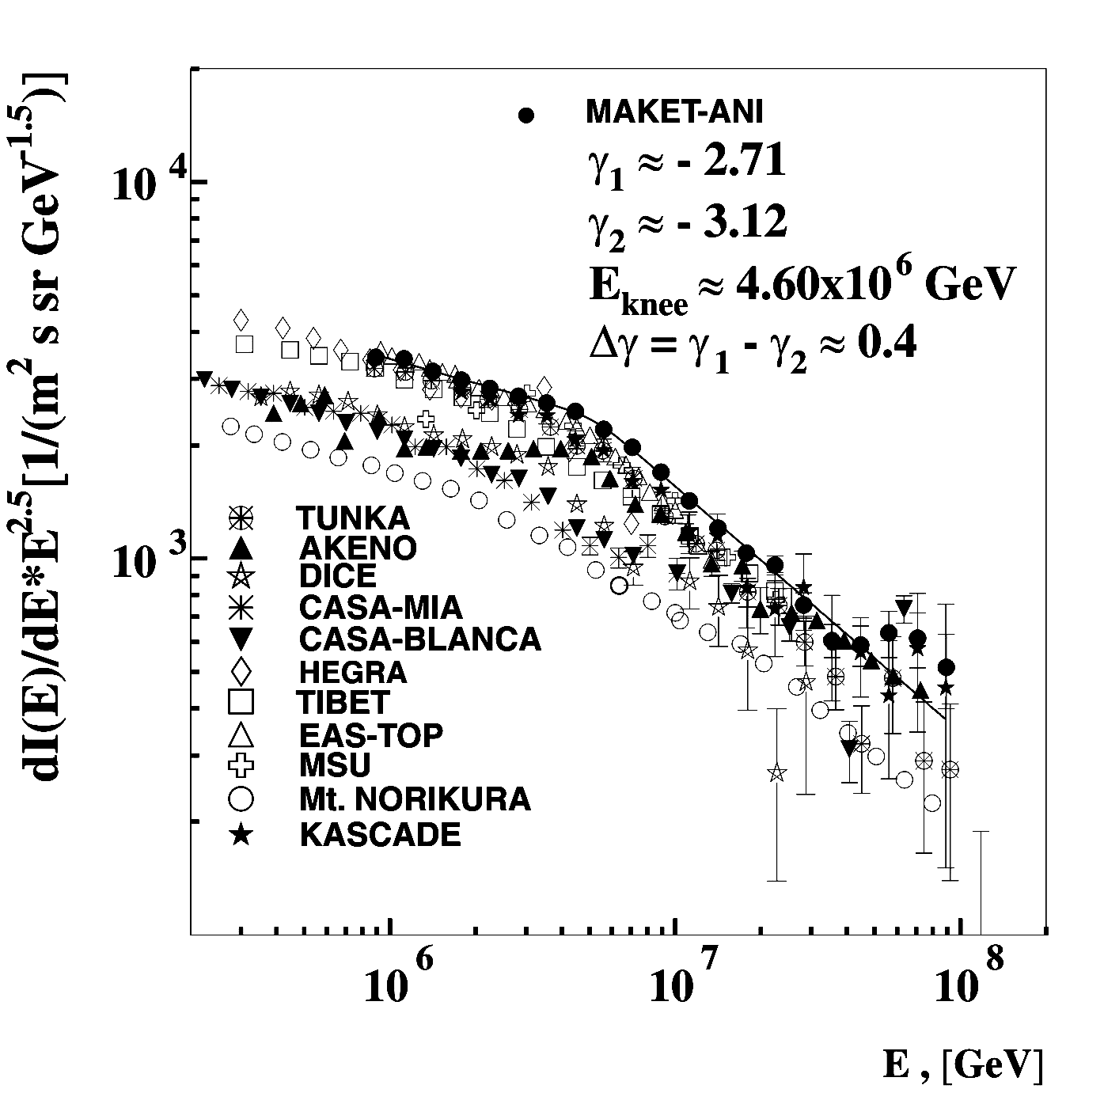
Fig. 15. The all particle spectrum from MAKET-ANI data compared to the world data. The line shows the fit to MAKET-ANI data (integrated into 0–30 zenith angle interval). KASCADE, EASTOP, TIBET, HEGRA, AKENO, CASA-MIA, CASA-BLANCA), DICE, Mt. NORIKURA, MSU, and TUNKA.
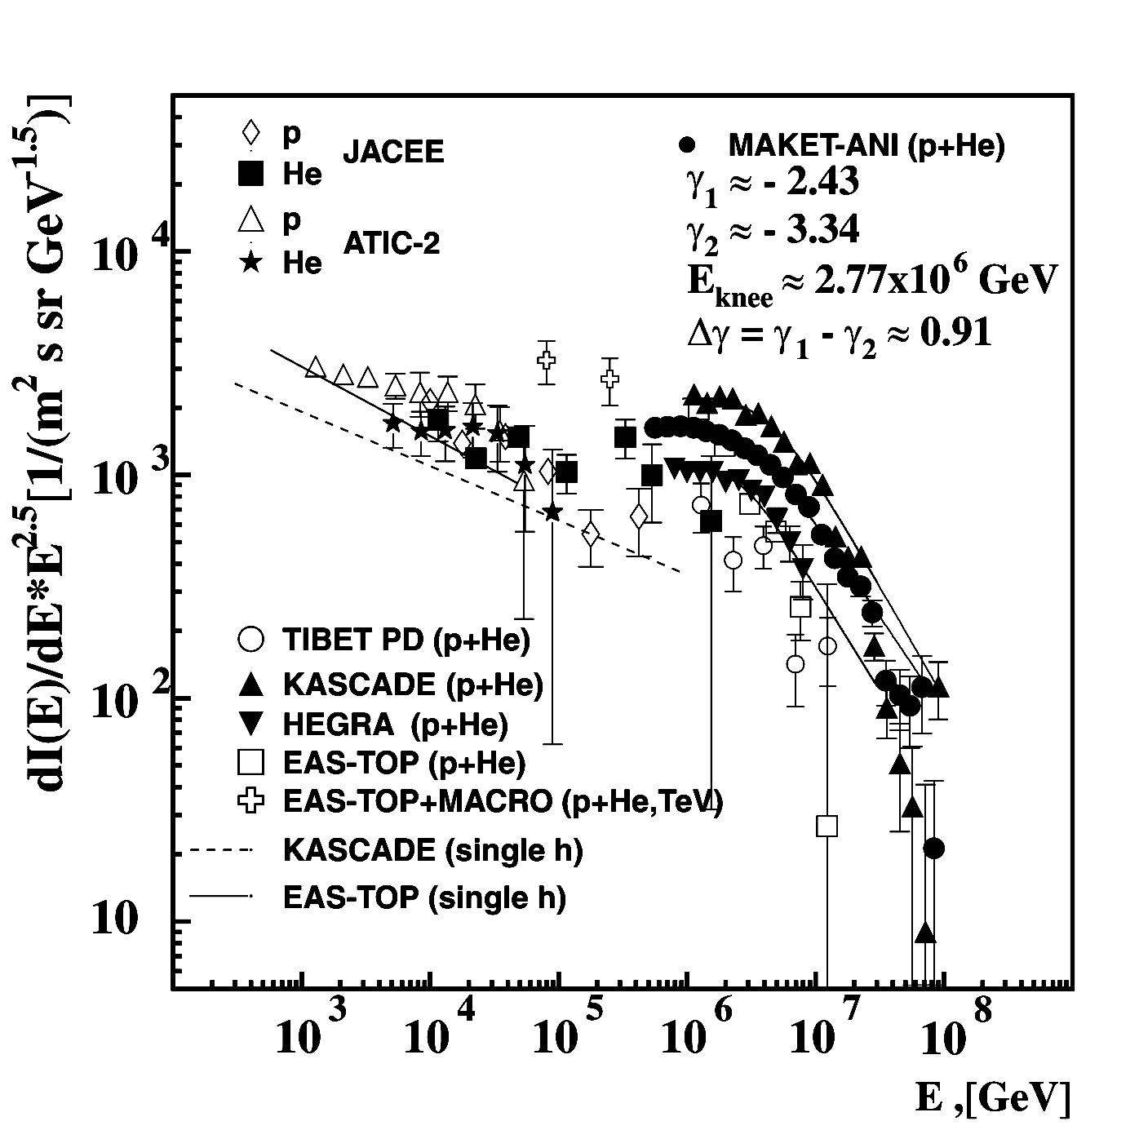
Fig. 16. Primary light component (p + He) measured by the MAKETANI detector in comparison to the results from KASCADE, EAS-TOP, HEGRA, EAS-TOP +MACRO, TIBET and primary protons spectra approximations obtained by the single hadrons fluxes EAS-TOP and KASCADE. The direct balloon measurements by ATIC-2 and JACEE at 102–105 GeV are also presented.
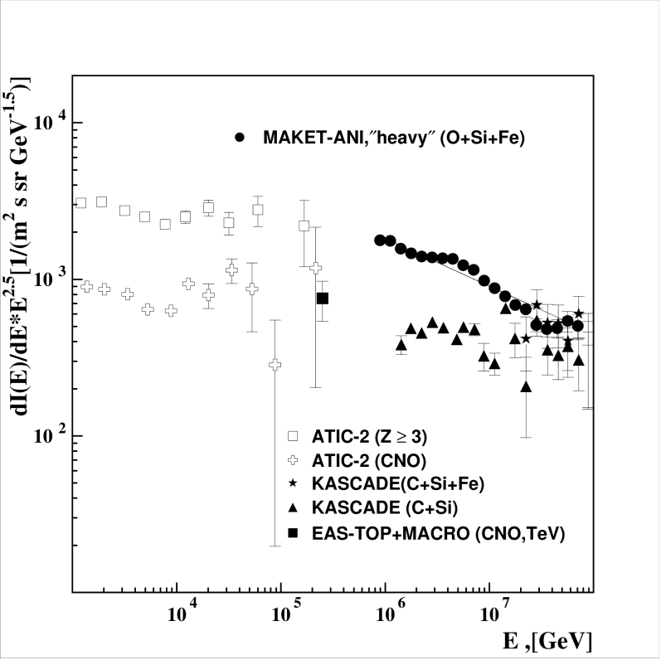
Fig. 17. The energy spectrum of the ‘‘heavy’’ nuclei group measured by the MAKET-ANI detector along with spectra from KASCADE, EASTOP + MACRO and ATIC-2. The solid line is a power function approximation.

