Lightnings and Particle Fluxes from Thunderclouds

A.Chilingarian, Y.Khanikyants, G.Hovsepyan and S.Soghomonyan,

*Yerevan Physics Institute,*

Alikhanyan Brothers st. 2, Yerevan, Armenia, 0036

chili@aragats.am

**Abstract–We add to lightning research new key evidence -*in situ* observations of the Thunderstorm Ground Enhancements (TGEs), i.e. enhanced fluxes of electrons, gamma rays and neutrons detected by particle detectors located on Mt. Aragats in Armenia. Simultaneously we monitor atmospheric discharges by detecting fast electric field waveforms and near-surface electrostatic field by a network of electric mills. Synchronized observation of TGEs and atmospheric discharges facilitates investigations of the long-standing lightning initiation problem.**

Keywords — high-energy physics in atmosphere, lightning, thunderstorms

# Introduction

Considered the highest mountain in the South Caucasus, Aragats is a dormant volcano with a 400 m deep crater that has become an ice basin. Its central highlands cover an area of more than 820 square kilometers and generate huge summer storms that flow down its slopes into the surrounding valleys. The four crests that top Mt. Aragats are simple reminders of its once soaring heights leveled over 10, 000m 1.5 million years ago, before a massive eruption lowered the height to its current 4,095m. Only in 100 km to the south from Aragats across the valley of the Araks River stands sister of Aragats – Biblical Mountain Ararat. Lightning activity is enormously strong at Aragats that makes it home of the ancient Armenian god of thunder and lightning Vahagn.  Mt. Aragats hosted one of the world’s oldest and largest cosmic ray research stations, located on the slopes of the mountain. The Cosmic Ray Division (CRD) of the A. Alikhanyan National lab (Yerevan Physics Institute) during the last 70 years has commissioned and operated on the research stations of Aragats and Nor Amberd numerous particle detectors, which uninterruptedly registered fluxes of charged and neutral cosmic rays. The research work at Aragats (in the framework of Aragats Space Environment center (ASEC, Chilingarian et al., 2005) includes registration of Extensive Air Showers (EAS) with large particle detector arrays; investigation of solar-terrestrial connections; monitoring of space weather; and observations of high-energy particles from the thunderclouds. More than 300 particle detectors (including plastic scintillators and NaI spectrometers) are registering particle fluxes and sending data online to the CRD headquarters in Yerevan. In addition to particle detectors, ASEC includes facilities that can measure electric and geomagnetic fields, lightning occurrences and locations, and a variety of meteorological parameters. With installing in 2014 fast electric field recorders and automotive cameras the research in the lightning physics started on Aragats. ASEC facilities are located on the slopes of Mt. Aragats and in Yerevan at altitudes of 3200, 2000, and 1000 m above sea level, respectively (see Fig. 1). The distance between Nor Amberd and Aragats research stations is 12.8 km. The distance from the CRD headquarters in Yerevan to the Nor Amberd and Aragats research stations is 26.5 and 39.1 km, respectively. The Latitude and Longitude coordinates of the stations are 40.3750° N, 44.2640° E for the Nor Amberd Station, 40.4713° N and 44.1819° E for the Aragats Station, and 40.2067° N and 44.4857° E – for the Yerevan Physics Institute.

Thunderstorm Ground Enhancements (TGEs, [Chilingarian et al., 2010, 2011] are abrupt enhancements of the secondary cosmic rays measured on the Earth’s surface in correlation with thunderstorms and lasting from several tens of seconds to several tens of minutes. The origin of TGEs are the very strong electric fields in the thunderclouds; if all electrostatic fields induced by the charge layers in the thundercloud join in a resulting field that accelerates the electrons downwards, the seeds from the ambient population of Cosmic Rays (CR) can gain energy from the field, multiply and produce bremsstrahlung gamma rays which are registered at the Earth’s surface. Plenty of the seed electrons originate from the multiple Extensive Air Showers (EASs) unleashed by the galactic high-energy protons and stripped nuclei interacting with the atmosphere.

The mechanism of the acceleration and multiplication of seed electrons, namely Runaway Breakdown (RB), was suggested in [Gurevich et al., 1992] along with emphasizing its role in the lightning initiation. This mechanism recently is referred to also as Relativistic Runaway Electron avalanches (RREAs, see reviews [Dwyer, Smith, and Cummer, 2012] and [Dwyer and Uman, 2014] for references). RB operates only at very high electric fields in the cloud and is capable to originate TGEs with energies up to 40-50 MeV and intensities tens of times exceeding the cosmic ray background [Chilingarian, et al., 2013]. In [Chilingarian, Mailyan and Vanyan, 2002] was proposed a compatible with RB mechanism – MOdification of electron energy Spectra (MOS), which can increase the secondary cosmic ray flux by a few fractions of a percent, but in a larger energy scale. In [Gurevich et. al., 1999] it was suggested, that when the electric field in a thunderstorm cloud reaches the critical value, every cosmic ray secondary electron with “runaway” energies (0.1 – 2 MeV) initiates a micro-runaway breakdown (MRB). Usually it is very difficult to select these nanosecond-lasting showers originated in the cloud from the individual electrons (Extensive Cloud Showers – ECSs) within the ongoing TGE of several minutes duration. ECSs (MRBs) should be distinguished from the plenty of medium and large EASs originated high in the atmosphere and containing millions of particles. Nonetheless, at Aragats research station where clouds sometimes are “sitting” on the surface we detect several large TGEs, within which “resolve” numerous very short (< 400 nsec) showers originated in the thundercloud from a seed electron [Chilingarian et al., 2011]. Furthermore, by the 2-way classification we demonstrate systematic differences of ECS and EAS. Thus, TGEs are superposition of the multiple avalanches initiated by the individual CR electrons in thundercloud and reaching the Earth’s surface.



Figure 1. The Google map of Armenia with Aragats Mountain (in the left upper corner) with Aragats and Nor Amberd research stations and Yerevan headquarters of CRD.

The relation of RBs, TGEs and lightnings are not yet fully discovered. If we can definitely state that RB is capable to initiate a TGE and a lightning cannot initiate a TGE [Chilingarian, 2014], then the role of RB in lightning initiation is still dimmed. For proving this theory we need simultaneous and synchronized on nanosecond time scales detection of TGEs and lightnings by particle detectors with fast electronics, detectors of the fast waveforms of radio emission, sensitive fast cameras, precise lightning detectors and electrostatic field sensors. Certainly, *in-situ* measurements of the electric field in the cloud will be very helpful. Unfortunately to date there are no convincing experiments for solving the lightning origination enigma.

In the report we demonstrate that experimentally measured patterns of the near-surface electrostatic field during TGEs are consistent with tripole structure of the cloud electrification. The maximal particle flux and the gamma ray energy spectra coincide with the special pattern of the disturbances of the near surface electrostatic field–the “bumps” arising from deep negative electrostatic field domain. These feature we identify with development of mature Lower Positively Charge Region (LPCR); afterwards the electric field in the cloud got enough strength to unleash the Runaway Breakdown (RB) process accelerated electrons downward in the direction of earth.

We also perform an analysis of a special kind of TGEs, i.e. TGEs abruptly terminated by lightnings. To our knowledge, the Baksan group reported the first TGEs of this kind [Alexeenko et. al., 2002]. They demonstrated that the particle count rate increased at energies of ~30 MeV then quickly returned to the background level when lightning occurred. In [Khaerdinov and Lidvansky, 2005] they correctly deduce that the detected flux enhancements are not directly related to the lightning activity; the lightnings serve rather as a switch-off for the electric field. Recently several groups report such special TGEs as well [Tsuchiya H. et al., 2013, Chilingarian et al., 2015, Kelley et al., 2015, Kollarik et al., 2016, Kuroda et al., 2016].

# Patterns of the disturbances of electrostatic field and dynamics of TGEs

In Fig. 2 we show a large TGE occurred on August 28 2015. At 23:15 near-surface electrostatic field being already in negative domain (-12 kV/m) started to decrease; TGE started at the same time from the mean value of 2690 +/- 78 (2-sec time series of 60 cm thick, 1 m2 area plastic scintillator). At 23:18 electrostatic field drops until -24 kV/m and TGE reaches the maximum of ~2890 (~7% excess) and sustains near the maximal flux 1.5 minutes, until 23:19:30. With the TGE flux reaching the maximum, the near-surface electrostatic field starts to rise, reaching -14 kV/m at 23:19:30. After 23:19:30 TGE slowly fades, recovering the “pre-TGE” value at 23:28. The electrostatic field abruptly declines, reaching -27 kV/m at 23:20; after reaching the minimum, it starts to rise again, touching the positive domain at 23:23 and reaching +9 kV/m in 30 seconds. Thus, at the TGE maximal flux, we see a well-developed bump of 12 kV/m amplitude and 2 minutes duration coinciding in time with the TGE maximal flux on the rising phase.

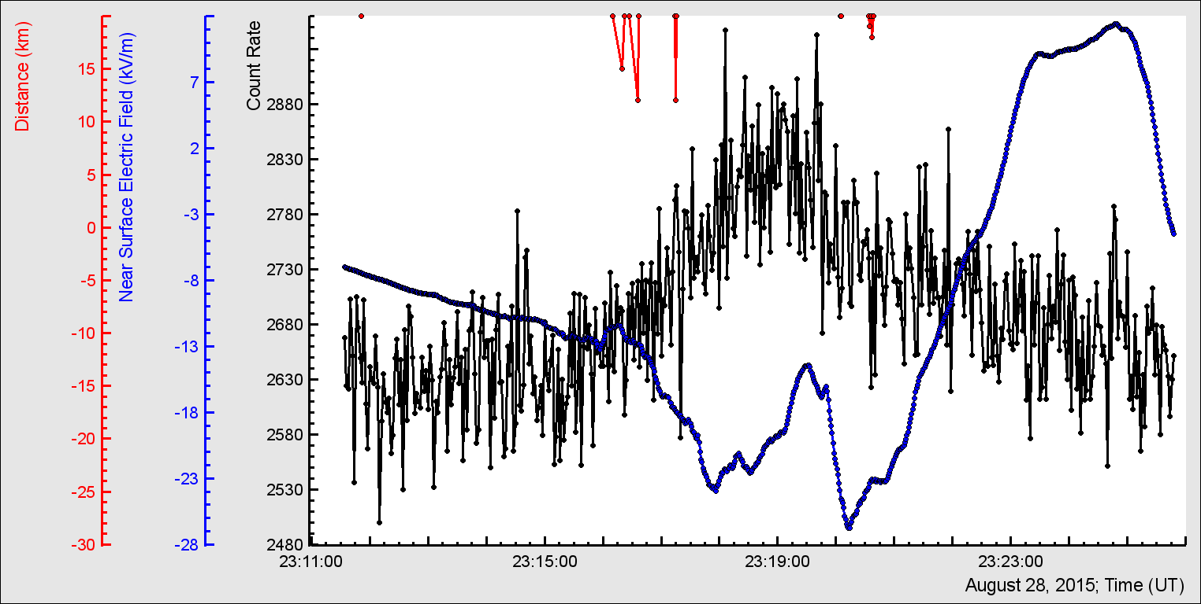

Figure 2. 2-second time series of 60 cm thick and 1 m2 area plastic scintillator and 1-sec time series of near-surface electrostatic field with a “bump” at particle maximal flux; on the top – distance to lightning.

The emerging structure in the near-surface electrostatic field time series is comparable with the structure from the calculated superposition of the electrostatic field induced by 3 charges, mimicking a tripole structure of the thundercloud. Of course, the theoretical curve reveals the spatial distribution of the electrostatic field and the experimental ones – temporal distribution. However, the wind during TGEs is moving the cloud above the particle detectors “mapping” the space distribution of the electric field in the cloud to the temporal one.

We speculate that when the mature LPCR arrives (or emerges) above the detector location, the lower dipole accelerates the electron in the direction of the earth, providing a maximal flux of bremsstrahlung gamma rays. The electron flux reaches its maximum when LPCR is above the detectors, and when the cloud moves away from the detector site, the TGE subsequently terminates.

Another example of a “featured” image of the near-surface electrostatic field and related TGE we show in Fig. 3. TGE is again measured by a network of 25 five cm thick 1 m2 area scintillators. Prolonged TGE, lasting 35 minutes, demonstrates several peaks (the largest is 13% height above the background, equivalent to 70σ statistical significance). Carefully examining the Figure we can outline several small “bumps” corresponding to TGE peaks above.

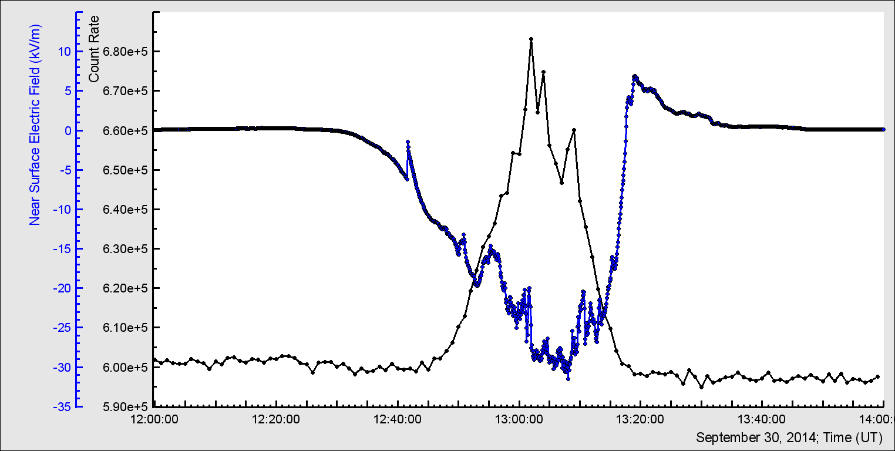

Figure 3. 1-minute time series of 5 cm thick plastic scintillator array and 1-sec time series of near-surface electrostatic field with several “bumps” corresponding to particle flux busts.

# TGEs terminated by lightning

The observation data involve 1 sec time series of the count rate of particle flux, 50 ms time series of slow disturbance of near-surface electrostatic field, fast wideband electric field waveforms, and lightning location and stroke energy data from WWLLN. Three successive attempts of TGE termination by lightnings are shown in Fig. 3.

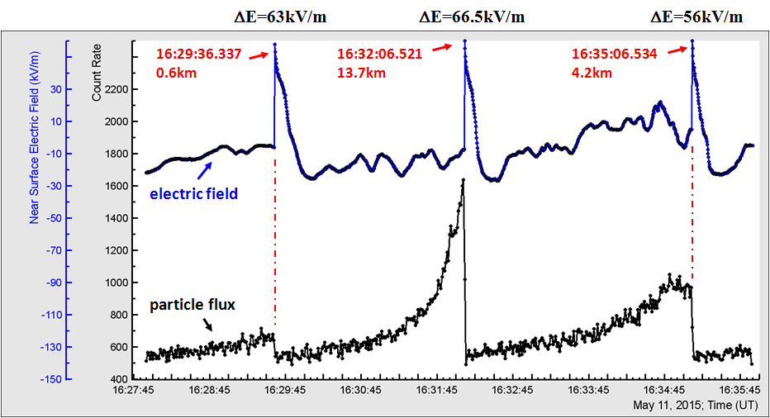

Figure 4 A sequence of TGEs abruptly terminated by negative lightnings. The lower curve is the 1 sec time series of the count rate of the particle flux detected by 3 cm thick outdoor scintillator, the upper curve is 50 ms time series of electrostatic field disturbances detected by the electric field mill. Lightning detection time and distance to the lightning according to WWLLN data, and electric field change ΔE are indicated for each lightning.

At 16:29:36, the electrostatic field starts its sharp increase, in 100 ms changing from −5.7kV/m to 57.3 kV/m, and count rate of particle flux is terminated at its rising edge. At 16:32:06, the electrostatic field changes from −6.5kV/m to 60 kV/m, and the termination is observed at the maximum of count rate. At 16:35:06, the electrostatic field changes from 5.5kV/m to 61.5kV/m, and the termination is observed at the declining of the count rate.

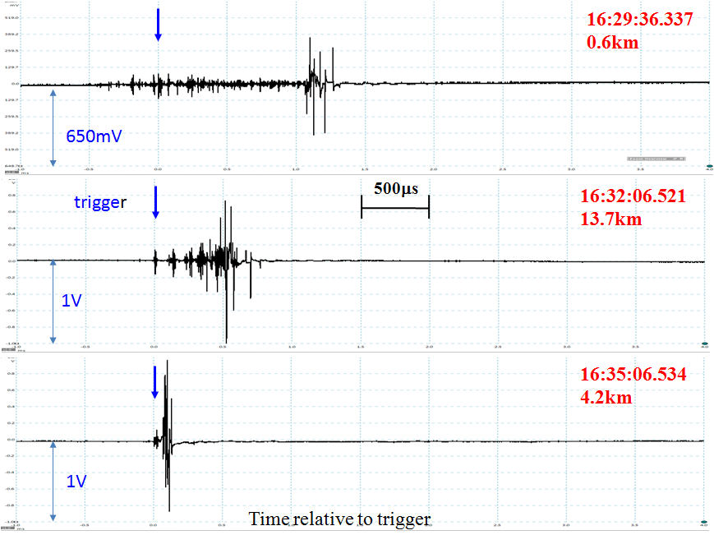

Figure 5. Fast electric field waveforms of three lightnings that terminated the TGEs shown in Figure 1. Data capture length is 5ms, including 1ms pre-trigger time, sampling frequency is 100Ms/s.

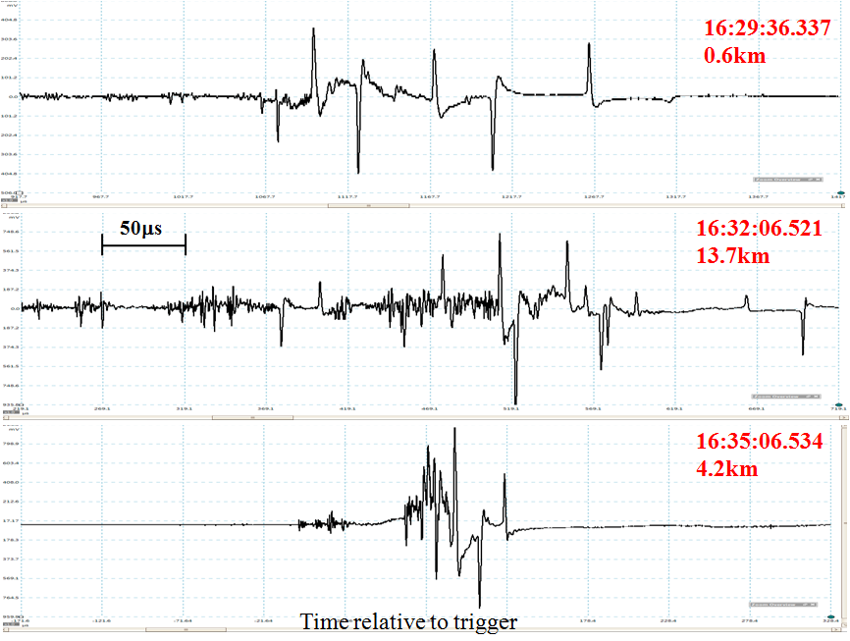

Figure 6. Fast electric field waveforms of Figure 2 are shown here with 10-fold time magnification. All three waveforms show multiple bipolar pulses with typical duration of 1-2 microseconds.

For all observed TGEs terminated by lightning, the electric field change measured at the ground is positive and it can be attributed to the decrease of negative charge overhead. The “atmospheric electricity” sign convention (a downward-directed electric field or field change vector is considered positive) is used throughout this paper. Thus, a positive electric field change measured at the ground is produced by a negative lightning, which decreases the negative charge overhead.

Fast electric field change waveforms for the three selected events are presented in Figs. 5 and 6 with different time magnification. All three waveforms show trains of multiple short bipolar pulses of different polarity with typical duration of 1-2 microseconds, and with overall train duration in the range from 150 μs to 1 ms.

# Lightning to TGE relation

On 7 October 2015, the weather at Aragats was stormy and thundery. The near-surface electrostatic field disturbances were registered by 7:00; they followed several lightnings at 12:00. Relative humidity during TGE was very high – 97%; atmospheric pressure – 685.3 mbar; wind speed 2.5 m/sec from

270°N direction. Solar radiation decreased from 500 W/m2 at 10:15 down to zero at 11:45. The temperature followed the decline of the solar radiation with a short delay, decreasing from 2.8 C° down to 0.5 C°. It means that a thick cloud was sitting just on the Aragats station. The location of the cloud above the particle detectors assisted the unleashing of the large TGE at 14:40 lasting ~5 minutes. All ASEC particle detectors registered a large enhancement of count rates reaching ~100 standard deviations (Nσ) for one-minute time series with detectors having an energy threshold of ~ 1 MeV and area 1 m2. Differential energy spectra measured by network of NaI spectrometers extends at least up to 30 MeV, see Fig 7.

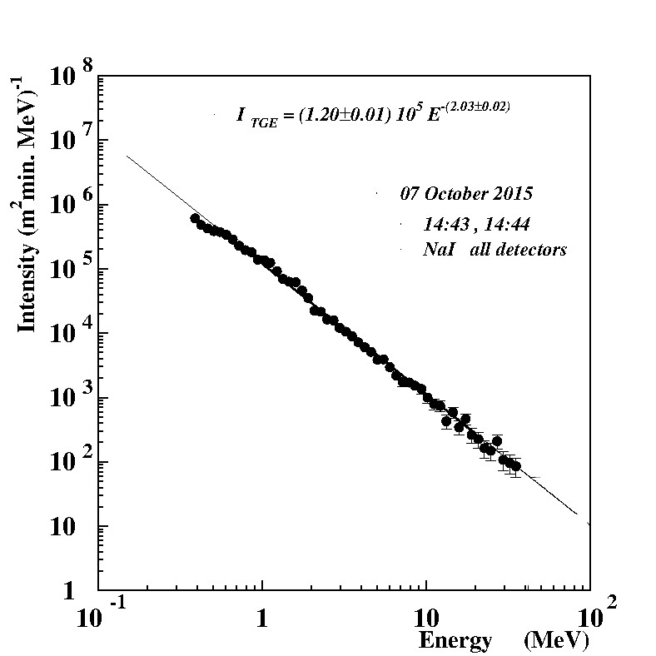

Figure 7. Differential energy spectrum of the TGE measured by the NaI spectrometers with energy threshold 0.4 MeV

The integral near-vertical energy spectra of the TGE event measured by the CUBE detector (energy threshold ~ 4 MeV) with capability of separating electron and gamma ray fluxes was: Ie ~ 350/m2min; Iγ ~ 9500/m2min; and Ie/Iγ ~ 3.8%. The particle flux reached the maximum at ~14:44, and on the declining phase at 14:45:07 was “killed” by the negative lightning, see Fig. 8.

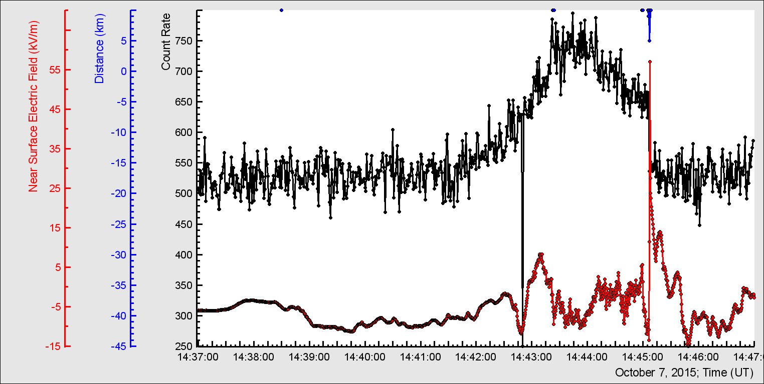

Figure 8 TGE abruptly terminated by the negative lightning; in the bottom – electrostatic field disturbances detected by the electric mill EFM-100; in the middle – 1 sec time series of the count rate of the 3 cm thick outdoor scintillator; on the top – distance to lightning. Lightning occurred at 14:45:07 coincides with the decline of particle flux by 14.4%.

In Fig. 9 we demonstrate five seconds of the 50-ms time series of the count rates including abrupt increase of the near-surface electrostatic field and particle flux termination. A visible decline of the particle flux occurred within 100 ms (from 14:45:07.175 to 14:45:07.275) coinciding with the abrupt increase of the near-surface electrostatic field after the return stroke, which deposited the negative charge on the ground. Detection of the fast electric field waveform was triggered at 14:45:06.995, that is ~ 180 ms prior to the abrupt termination of TGE.

Our statistics of the time difference between WWLLN time stamps and EFM-100 field maximum time stamps (137 coinciding detections, see Fig. 5 in [Chilingarian et.al., 2016]) also shows a delay of the electrostatic field maximal value comparing with lightning strike registered by WWLLN of ~ 185ms.

The electric field measurements are fed to the myRio board by the TCP-IP connection (Wi-Fi) scaled ~ 5 times less than the firmware application provided by Boltek via Internet cable [Pokhsraryan, 2016]. It explains the ~5-fold decrease of the electrostatic field strength of myRio output.

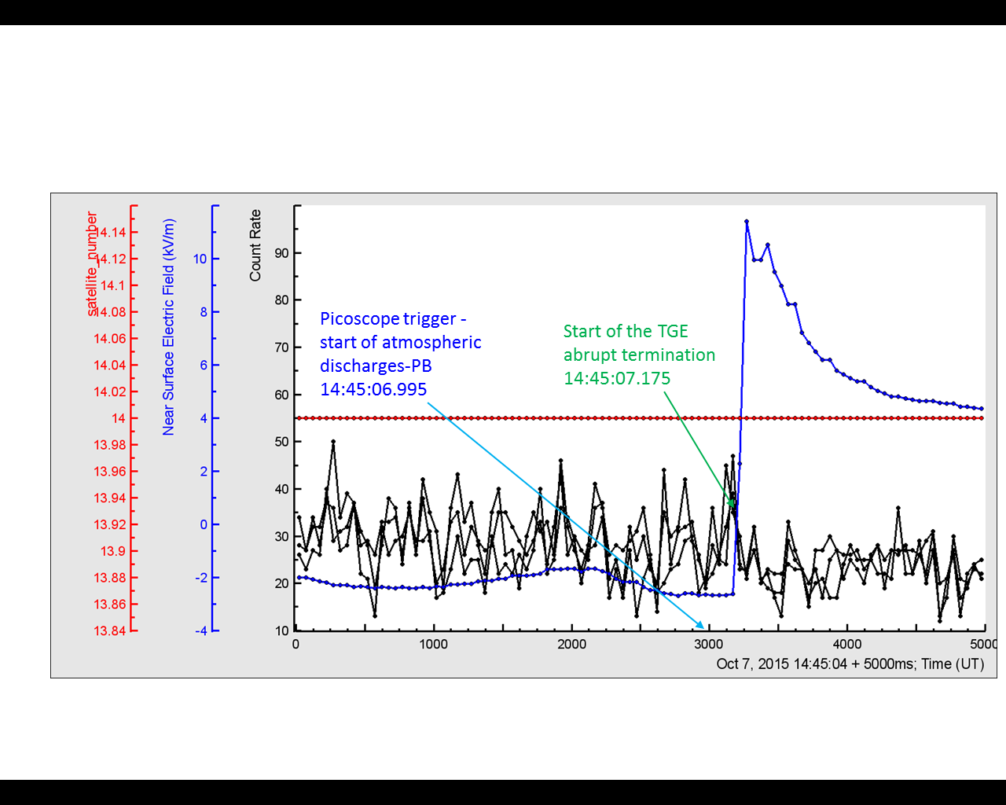

**Figure 9. Five seconds of 50 ms time series of all 3 layers of the STAND1 detector (located near SKL hall) before and after sharp decline of particle flux at 14:45:07.225. The flux decline coincides with an abrupt increase (100ms rise time) of the near-surface electrostatic field. 14 GPS satellites participate in the precise time synchronization.**

# Conclusion

From the observed patterns of electrostatic field disturbances during the TGE occurrences we deduce that rising “bumps” in the time series are an essential characteristic of a thunderstorm, evidencing creation of the LPCR and development of a large TGE, as a rule. The experimentally measured patterns of the near-surface electrostatic fields during TGEs are consistent with a tripole structure of the calculated electrostatic field in the cloud. The maximal particle flux coincides with the “bumps” rising from negative electrostatic field. This feature we categorize with the development of mature LPCR, which with the main negative charge layer above forms a dipole and accelerates electrons downward in the direction to the earth. In (Chilinarian et al., 2016) we demonstrate that 3 electrostatic fields from the tripole structure of the electrified thundercloud contribute to the resulting field that accelerates electrons downward. The LPCR, as the nearest to the Earth positively charged layer, has the biggest impact on the development of the resulting accelerating field and hence – on the TGE initiation.

Thus, the scenario of the TGE development [Chilingarian, 2014] finds its proof also in the measured shapes of the electrostatic field disturbances during TGEs observed on Aragats.

However, the large variability in duration, amplitude and shape of TGEs detected by ASEC facilities [see Chilingarian, Karapetyan and Melkumyan, 2013] as well as fluctuating patterns of the near-surface electrostatic field disturbances support different scenarios of the emergence of an electric field strong enough to accelerate electrons downwards. There was recently discovered a downward RREA that occurred between the negative screening layer and the upper positive charge layer just below it [Kelly et al., 2015]. Following this discovery, we can consider the possibility of particle flux initiation by the electric field originated between the main negatively charged region and its “charge image” of the opposite sign on the ground. Extension of the negative layer’s image should be much larger than the size of the LPCR due to much smaller size of the LPCR.

On 7 October 2015, ASEC particle detectors fixed a large TGE event. The one-minute time series of the low-threshold detectors demonstrate a huge enhancement, equivalent to ~ 100 standard deviations. The differential energy spectrum of gamma rays extends to 30 MeV and more. The strong negative lightning seen as an abrupt enlarging of the near-surface electrostatic field with an amplitude of ~ 70 kV/m terminates the particle flux. On the 50 ms time scales we can see that the TGE decay started simultaneously with the abrupt increase of the near-surface electrostatic field. Therefore, the initiation and termination of TGE is directly connected with the rearranging of the charged structures in the thundercloud, the most important of which is development and decay of the LPCR.

We assume that the magnitude of the particle accelerating field, and hence the particle flux intensity, depend on the matureness (thickness) of LPCR. At the maximum of particle flux the LPCR is mature and thick, whereas at the beginning and at the decay phase the LPCR is thin. Although, 3 TGEs terminated by lightning (Fig. 4) are equally distributed by 3 categories: terminated in the beginning, at the maximum and on the decaying phase. It contradicts the model of the LPCR development and decay presented in [Nag and Rakov, 2009]. According to their model, the negative lightning leader can penetrate LPCR only in its decaying phase. The mature LPCR do not allow the negative leader to punch through and change it to intracloud lightning. Thus, maybe there are another players that influence the lightning initiation much more than the thickness of LPCR; i.e. the very large EAS occasionally hitting the cloud and unleashing –CG by the RB-EAS mechanism [Gurevich et al., 1999].

##### Acknowledgment

The authors thank the staff of the Aragats Space Environmental Center for the uninterruptible operation of Aragats research station facilities. The data for this paper are available via the multivariate visualization software ADEI on the WEB page of the Cosmic Ray Division (CRD) of the Yerevan Physics Institute, http://adei.crd.yerphi.am/adei. Authors thank E.Mareev, H.Gemmeke, M.Briggs and N. Kelley for useful comments. The authors wish to thank the World Wide Lightning Location Network ([http://wwlln.net](http://wwlln.net/)), for providing the lightning location data used in this paper.

##### References

Alexeenko V.V., KhaerdinovN.S.,LidvanskyA.S., and PetkovV.B., (2002), Transient Variations of Secondary Cosmic Rays due to Atmospheric Electric Field and Evidence for Pre-Lightning Particle Acceleration, *Physics Letters A*, 301, 299-306.

Chilingarian, A., Arakelyan, K., Avakyan, K.et al. (2005), Correlated measurements of secondary cosmic ray fluxes by the Aragats space-environmental center monitors, Nucl. Instrum. Methods A 543 (2–3) 483.

Chilingarian, A., A. Daryan, K. Arakelyan, A. Hovhannisyan, B. Mailyan, L. Melkumyan, G. Hovsepyan, S. Chilingaryan, A. Reymers, and L. Vanyan L. (2010), Ground-based observations of thunderstorm-correlated fluxes of high-energy electrons, gamma rays, and neutrons, Phys. Rev. D, 82, 043009.

Chilingarian, A., Hovsepyan, G., Hovhannisyan, A. (2011), Particle bursts from thunderclouds: natural particle accelerators above our heads. Phys. Rev. D: Part. Fields 83 (6), 062001.

Chilingarian, A., Mkrtchyan, H. (2012), Role of the lower positive charge region (LPCR) in initiation of the thunderstorm ground enhancements (TGEs). Phys. Rev. D: Part. Fields 86, 072003.

Chilingarian A., Hovsepyan G., and Kozliner L., (2013), Thunderstorm ground enhancements: Gamma ray differential energy spectra, Physical Review D 88, 073001.

Chilingarian A., Thunderstorm Ground Enhancements - model and relation to lightning flashes (2014), Journal of Atmospheric and Solar-Terrestrial Physics 107 68–76.

## Chilingarian A., Mailyan B. and Vanyan L., (2012), Recovering of the energy spectra of electrons and gamma rays coming from the thunderclouds, Atmospheric Research 114–115 ,1–16.

Dwyer J.R. Smith D.M., Cummer S.A. (2012), High-energy atmospheric physics: terrestrial gamma-ray flashes and related phenomena, Space Sci. Rev. 173 133.

Chilingarian A., Hovsepyan G., Khanikyanc G., Reymers A. andSoghomonyan. S. (2015), Lightning origination and thunderstorm ground enhancements terminated by the lightning flash, EPL, 110, 49001.

Chilingarian, A., Chilingaryan S., and Reymers A. (2015), Atmospheric discharges and particle fluxes, J. Geophys. Res. Space Physics, 120(7), doi:10.1002/2015JA021259.

Chilingarian A., Khanikyanc G., Kozliner L. andSoghomonyan S., 2016. Fast electric field waveforms and near-surface electric field images of lightning discharges detecte on Mt. Aragats in Armenia , Proceedings of TEPA 2015, Nor Amberd, Tigran Metz.

Dwyer J.R., Uman M.A. (2014) The physics of lightning, Phys. Rep. 534, 147.

Gurevich A.V., MilikhG.M. andRouseel-Dupre R, (1992), Runaway electron mechanism of air breakdown and preconditioning during a thunderstorm, Physics Letters A 1992, v.165, pp.463 – 468.

Gurevich A.V., ZybinK.P, Roussel – Dupre R.A., (1999), Lightning initiation by simultaneous of runaway breakdown and cosmic ray showers*,* Phys.Lett. A 254, 79.

Kollarik M., Kudela K., Langer R., Strharsky I., (2016), First results from the measuring equipment SEVAN on Lomnickýštít and possible connections with atmospheric phenomena, Proceedings of TEPA 2015, Nor Amberd, Tigran Metz.

Kuroda Y., Oguri S., Kato Y., et. al., (2016), Observation of gamma ray bursts at ground level under the thunderclouds, arXiv:1601.06349v2 [astro-ph.HE], submitted to Physics Letters B.

Kelley N.A., Smith D.M., Dwyer J.R., et al. (2015), Relativistic electron avalanches as a thunderstorm discharge competing with lightning, Nature communications, **6**,Article number:7845,DOI: 10.1038/ncomms8845.

KhaerdinovN.S., LidvanskyA.S., (2005), Cosmic rays and the electric field of thunderclouds: Evidence for acceleration of particles (runaway electrons) *,* Atmospheric Research 76, 346–354

Nag A. and Rakov V. A. (2009),Some inferences on the role of lower positive charge region in facilitating different types of lightning, Geophys. Res. Lett., 36  L05815.

Pokhsraryan D, (2016), Very fast Data Acquisition system based on NI-my RIO with GPS time stamping capabilities, Proceedings of TEPA 2015, Nor Amberd, Tigran Metz,

Soghomonyan S., Chilingarian A., Khanikyants Y, Kozliner L, (2016), Fast electric field waveforms of lightning discharges detected at the Aragats mountain in Armenia, Proceedings of TEPA 2015, Nor Amberd, Tigran Metz.

Tsuchiya H., EnotoT.,IwataK.,et al., (2013), Detection of high-energy gamma rays from winter thunderclouds,. Rev. Lett., 111, 015001.